4.47: a)
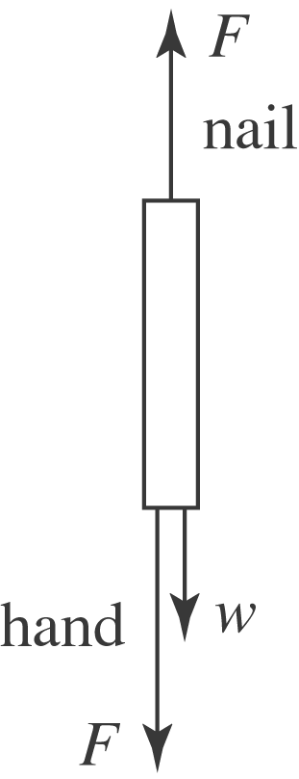

b) The acceleration of the hammer head will be the same as the nail, . The mass of the hammer head is its weight divided by 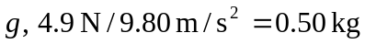, and so the net force on the hammer head is This is the sum of the forces on the hammer head; the upward force that the nail exerts, the downward weight and the downward 15-N force. The force that the nail exerts is then 590 N, and this must be the magnitude of the force that the hammer head exerts on the nail. c) The distance the nail moves is .12 m, so the acceleration will be 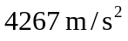, and the net force on the hammer head will be 2133 N. The magnitude of the force that the nail exerts on the hammer head, and hence the magnitude of the force that the hammer head exerts on the nail, is 2153 N, or about 2200 N.

